**SMART SOLUTIONS FOR RAILWAYS**

***SUMBITTTED BY***

**TEAM ID: PNT2022TMID00940**

**Aravind G - 211419106030**

**Abinesh B - 211419106005**

**Avinash AJ - 211419106037**

**Allan Germanus S - 211419106025**

***In the partial fulfillment of the award of the degree of***

**BACHELOR OF ENGINEERING**

**In**

**Electronics And Communication Engineering**

**Panimalar Engineering College**

**Chennai-6000123**

**NOV-2022**

**ANNA UNIVERSITY : CHENNAI**

**BONAFIDE CERTIFICATE**

Certified that this project report **“SMART SOLUTIONS FOR RAILWAYS”** is the bonafide work of **“ARAVIND G (211419106030) , ABINESH B (211419106005) , AVINASH AJ(211419106037) , ALLAN GERMANUS S (211419106025)** who carried out the project work under supervision of Faculty Mentors and Industry Mentors .

CONTENTS

1. **INTRODUCTION**

Project Overview

Purpose

1. **LITERATURE SURVEY**
   1. Existing problem
   2. References
   3. Problem Statement Definition
2. **IDEATION & PROPOSED SOLUTION**
   1. Empathy Map Canvas
   2. Ideation &Brainstorming
   3. Proposed Solution

Problem Solution fit

1. **REQUIREMENT ANALYSIS**
   1. Functional requirement
   2. Non-Functional requirements
2. **PROJECT DESIGN**
   1. Data Flow Diagrams
   2. Solution & Technical Architecture
   3. User Stories
3. **PROJECT PLANNING & SCHEDULING**
   1. Sprint Planning & Estimation
   2. Sprint Delivery Schedule
   3. Reports from JIRA
4. **CODING & SOLUTIONING (Explain the features added in the project along with code)**
   1. Feature 1
   2. Feature 2
   3. Database Schema (if Applicable)
5. **TESTING**
   1. Test Cases
   2. User Acceptance Testing
6. **RESULTS**
   1. Performance Metrics
7. **ADVANTAGES & DISADVANTAGES**
8. **CONCLUSION**
9. **FUTURE SCOPE**
10. **APPENDIX**

Source Code

GitHub & Project Demo Link

**INTRODUCTION**

**1. INTRODUCTION**

**1.1 PROJECT OVERVIEW**

Smart Solutions For Railways is to manage Indian Railways is the largest railway network in Asia and additionally world's second largest network operated underneath a single management. Due to its large size it is difficult to monitor the cracks in tracks manually. This paper deals with this problem and detects cracks in tracks with the help of ultrasonic sensor attached to moving assembly with help of stepper motor. Ultrasonic sensor allows the device to moves back and forth across the track and if there is any fault, it gives information to the cloud server through which railway department is informed on time about cracks and many lives can be saved. This is the application of IoT, due to this it is cost effective system. This effective methodology of continuous observation and assessment of rail tracks might facilitate to stop accidents. This methodology endlessly monitors the rail stress, evaluate the results and provide the rail break alerts such as potential buckling conditions, bending of rails and wheel impact load detection to the concerned authorities.

**1.2. PURPOSE**

Internet is basically system of interconnected computers through network. But now its use is changing with changing world and it is not just confined to emails or web browsing. Today’s internet also deals with embedded sensors and has led to development of smart homes, smart rural area, e-health care’s etc. and this introduced the concept of IoT . Internet of Things refers to interconnection or communication between two or more devices without human to-human and human-to-computer interaction. Connected devices are equipped with sensors or actuators perceive their surroundings. IOThas four major components which include sensing the device, accessing the device, processing the information of the device, and provides application and services. In addition to this it also provides security and privacy of data . Automation has affected every aspect of our daily lives. More improvements are being introduced in almost all fields to reduce human effort and save time. Thinkingof the same is trying to introduce automation in the field of track testing. Railroad track is an integral part of any company's asset base, since it provides them with the necessary business functionality. Problems that occur due to problems in rail roads need to be overcome. The latest method used by the Indian railroad is the tracking of the train track which requires a lot of manpower and is time-consuming.

**LITERATURE SURVEY**

**LITERATURE SURVEY**

**2.1 EXISTING SYSTEM**

In the Existing train tracks are manually researched. LED (Light EmittingDiode) and LDR (Light Dependent Resister) sensors cannot be implemented on the block of the tracks ]. The input image processing is a clamorous systemwith high cost and does not give the exact result. The Automated Visual Test Method is a complicated method as the video color inspection is implemented to examine the cracks in rail track which does not give accurate result in bad weather. This traditional system delays transfer of information. Srivastava et al., (2017) proposed a moving gadget to detect the cracks with the help of an array of IR sensors to identify the actual position of the cracks as well as notify to nearest railway station . Mishra et al., (2019) developed a system to track the cracks with the help of Arduino mega power using solar energy and laser. AGSM along with a GPS module was implemented to get the actual location of the faulty tracks to inform the authorities using SMS via a link to find actual location on Google Maps. Rizvi Aliza Raza presented a prototype in that is capable of capturing photos of the track and compare it with the old database and sends a message to the authorities regarding the crack detected. The detailed analysis of traditional railway track fault detection techniques is explained in table.

**2.2 REFERENCES**

1. D. Hesse, “Rail Inspection Using Ultrasonic Surface Waves” Thesis, Imperial College of London, 2007.

2. Md. Reya Shad Azim1 , Khizir Mahmud2 and C. K. Das. Automatic railway6 track switching system, International Journal of Advanced Technology, Volume 54, 2014.

3. S. Somalraju, V. Murali, G. saha and V. Vaidehi, “Title-robust railway crackdetection scheme using LED (Light Emitting Diode) - LDR (Light Dependent Resistor) assembly IEEE 2012.

4. S. Srivastava, R. P. Chourasia, P. Sharma, S. I. Abbas, N. K. Singh, “Railway Track Crack detection vehicle”, IARJSET, Vol. 4, pp. 145-148, Issued in 2, Feb 2017.

5. U. Mishra, V. Gupta, S. M. Ahzam and S. M. Tripathi, “Google Map BasedRailway Track Fault Detection Over the Internet”, International Journal of Applied Engineering Research, Vol. 14, pp. 20-23, Number 2, 2019.

6. R. A. Raza, K. P. Rauf, A. Shafeeq, “Crack detection in Railway track usingImage processing”, IJARIIT, Vol. 3, pp. 489-496, Issue 4, 2017.

7. N. Bhargav, A. Gupta, M. Khirwar, S. Yadav, and V. Sahu, “AutomaticFault Detection of Railway Track System Based on PLC (ADORTAST)”, International Journal of Recent Research Aspects, Vol. 3, pp. 91-94, 2016.

**2.3 PROBLEM STATEMENT DEFINITION**

Among the various modes of transport, railways is one of the biggest modes of transport in the world. Though there are competitive threats from airlines,luxury buses, public transports, and personalized transports the problem statement is to answer the question “What are the problems faced by the passengers while travelling by train at station and on board”.

Smart Solutions for railways is designed to reduced the work load of the user and also the use of paper.

**IDEATION AND PROPOSED SOLUTION**

**3. IDEATION AND PROPOSED SOLUTON**

**3.1 EMPATHY MAP CANVAS**

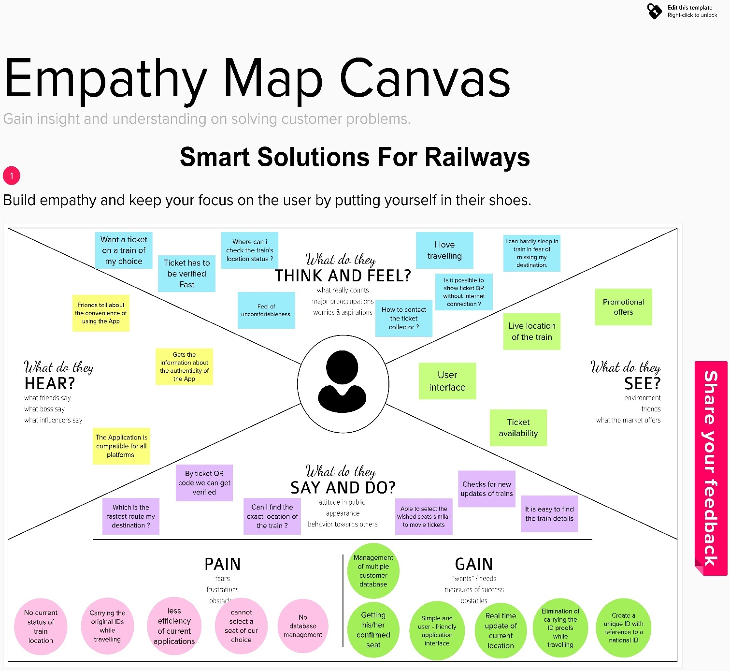

**3.2 IDEATION & BRAINSTORMING**

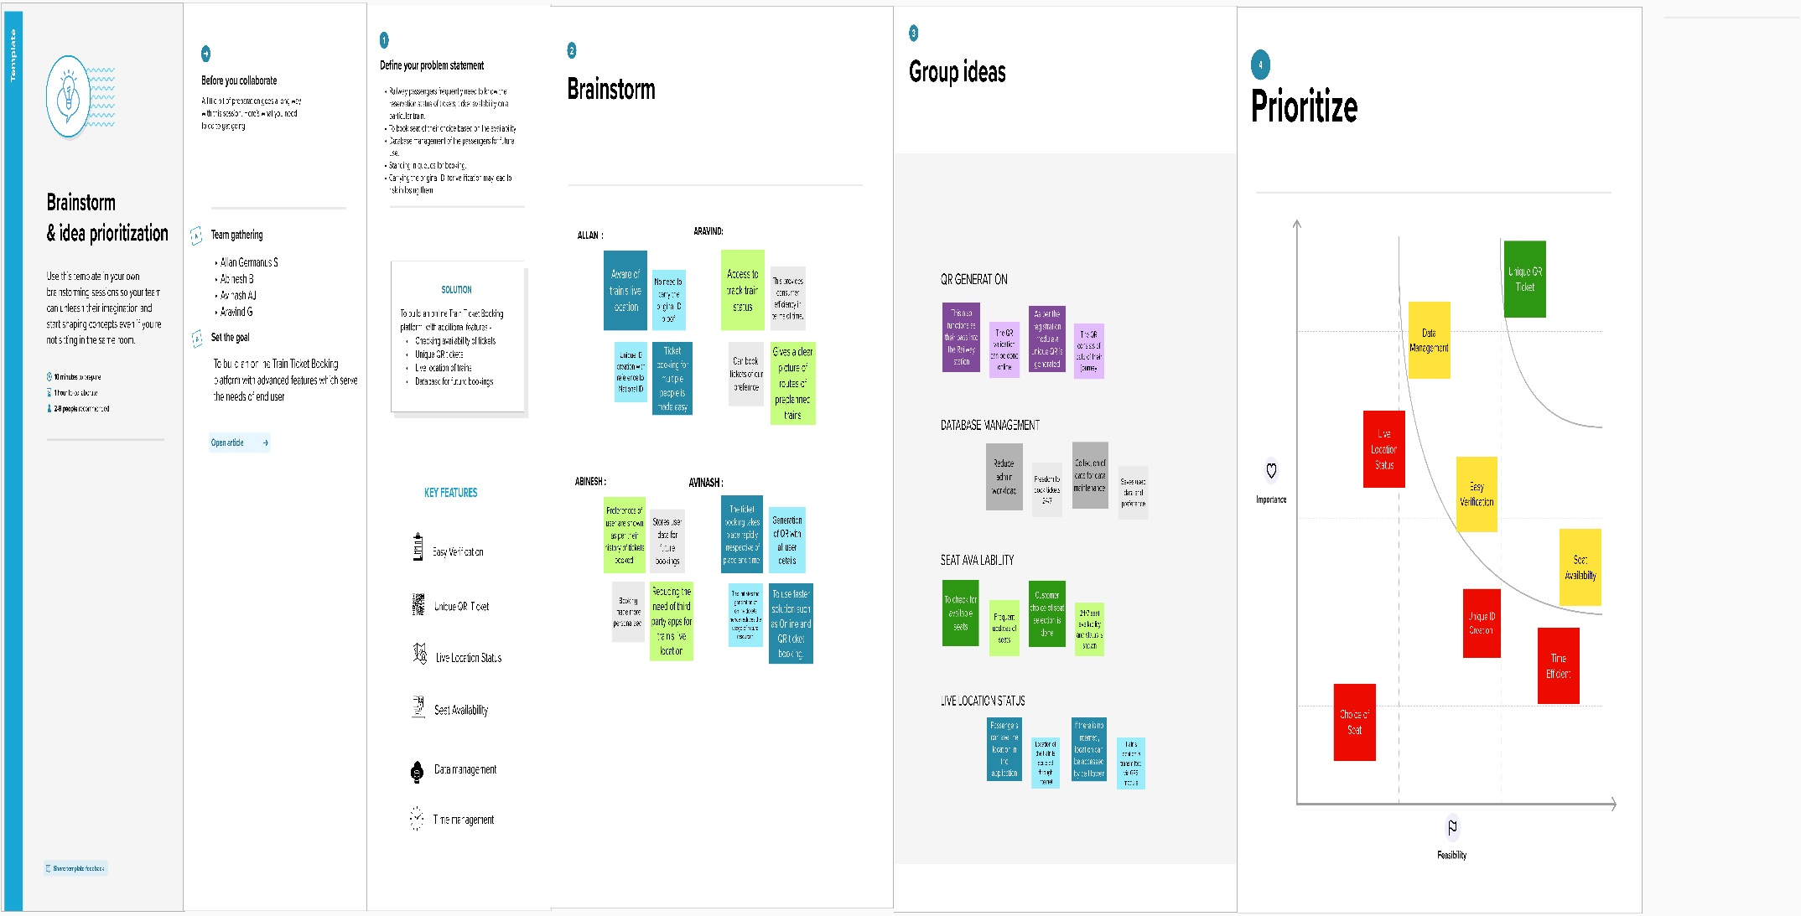

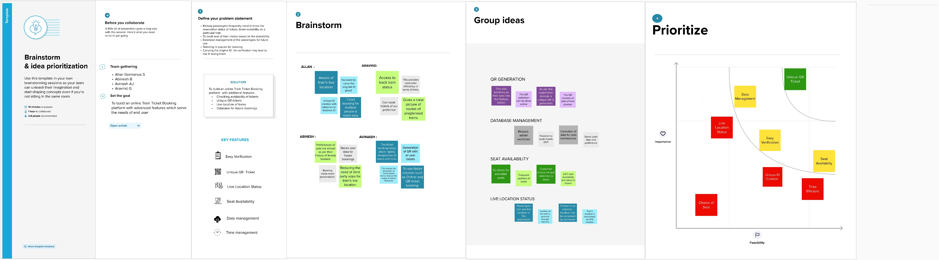

**3.3 PROPOSED SOLUTION**

|  |  |  |
| --- | --- | --- |
| **S.No.** | **Parameter** | **Description** |
|  | Problem Statement (Problem to be solved) | To maintain the tracks, repairs and services to avoid accident, safeguard of things, track the running status of the train in smart railway system and reach the destination place on time due to train delay. |
|  | Idea / Solution description | The idea is able to predict the delays in prior and helps to decide best alternatives to reduce delays. With the help of sensor to detect the crack in rail track with measuring the distance from the track to sensor to reduce the accidents. |
|  | Novelty / Uniqueness | Improving and increasing customer experience ,vehicle tracking system.IOT is used along with Al which provides enhanced features in finding out delays. |
|  | Social Impact / Customer Satisfaction | Predicting delay and detecting the train arrival time so that help the passenger to act accordingly and keep tracking the location of the train and travel in easy and modern way. |
|  | Business Model (Revenue Model) | Product and service sales to the railways system User booking and Scheduling Service it makes passengers to avoid delays which will make more number of people to shift to railway mode of transportation which increases the revenue of railways. |
|  | Scalability of the Solution | Using lot in railways, increased the use of trains among people due to its convenient usage.So it will automatically increase the both revenue and expenses, but the revenue will chase the expenses and will be boosting. |

**3.4 PROBLEM SOLUTION FIT**

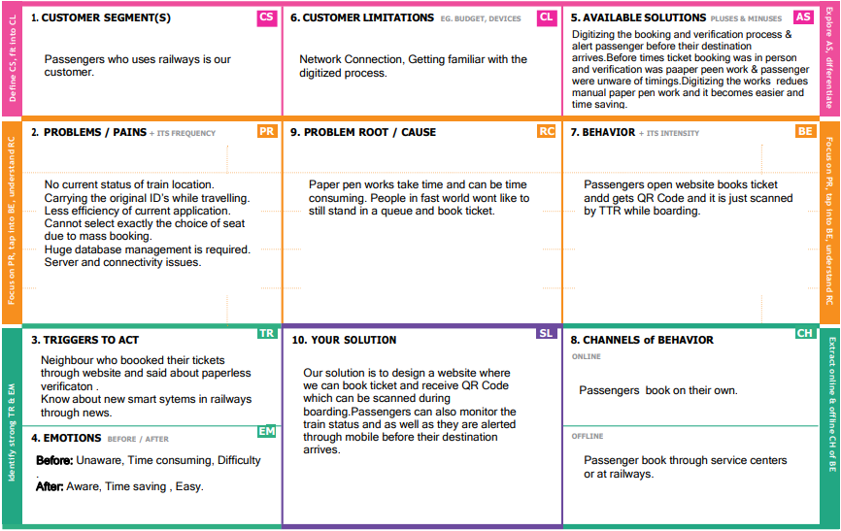

**REQUIREMENT ANALYSIS**

**4. REQUIREMENT ANALYSIS**

**4.1. FUNCTIONAL REQUIREMENTS**

|  |  |  |
| --- | --- | --- |
| **FR No.** | **Functional Requirement (Epic)** | **Sub Requirement (Story / Sub-Task)** |
| FR-1 | Passenger Registration | Registration through Application by providing the required Details |
| FR-2 | Passenger Login | Login Using the Unique Username and corresponding Password |
| FR-3 | Admin Login | Login Using the Admin Username and Password |
| FR-4 | Passenger Books Ticket | Books the Ticket through app by providing the Details required |
| FR-5 | Selecting the Seat | While booking passenger should select which seat is comfortable for him/her. |
| FR-6 | QR Code Generation | A QR Code is generated following a successful booking |
| FR-7 | Admin Cancel the Booking | If the information is inappropriate or the passenger is suspected to be an inappropriate person, admin can cancel his/her ticket. |
| FR-8 | Tracking the location of Train | Passenger can view the current location of his/her Train. |
| FR-9 | TTR Verifies the Passenger | TTR Scans the QR Code shown by the Passenger which gives the passenger Information that have to be verified. |

**4.2 NON-FUNCTIONAL REQUIREMENTS**

|  |  |  |
| --- | --- | --- |
| **FR No.** | **Non-Functional Requirement** | **Description** |
| NFR-1 | Usability | People with no high knowledge on using mobile can easily handle the application. |
| NFR-2 | Security | Access permissions for the particular system information may only be changed by the system’s data administrator. |
| NFR-3 | Reliability | The database update process must roll back all related updates when any update fails. |
| NFR-4 | Performance | The front-page load time must be no more than 2 seconds for users that access the website using an LTE mobile connection. |
| NFR-5 | Availability | New module deployment mustn’t impact front page, product pages, and check out pages availability and mustn’t take longer than one hour. The rest of the pages that may experience problems must display a notification with a timer showing when the system is going to be up again. |
| NFR-6 | Scalability | The website attendance limit must be scalable enough to support 10,000 users at a time |

**PROJECT DESIGN**

**5. PROJECT DESIGN**

**5.1 DATA FLOW DIAGRAMS**

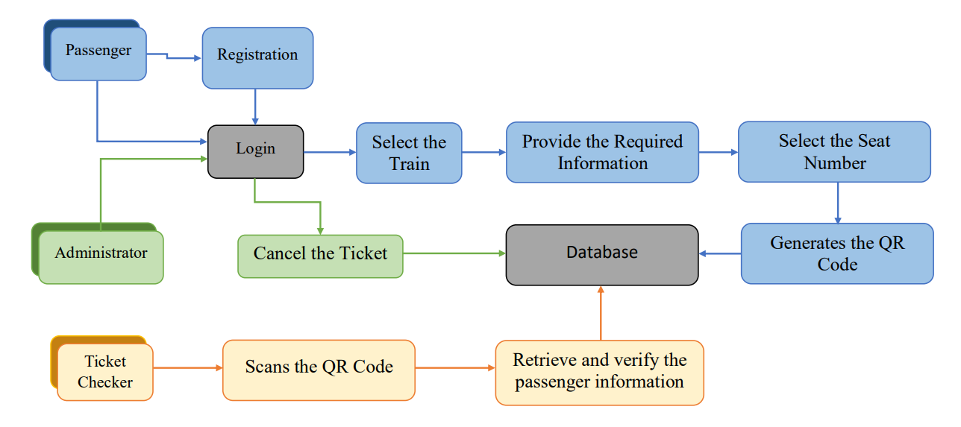

**5.2 SOLUTION & TECHNICAL ARCHITECTURE**

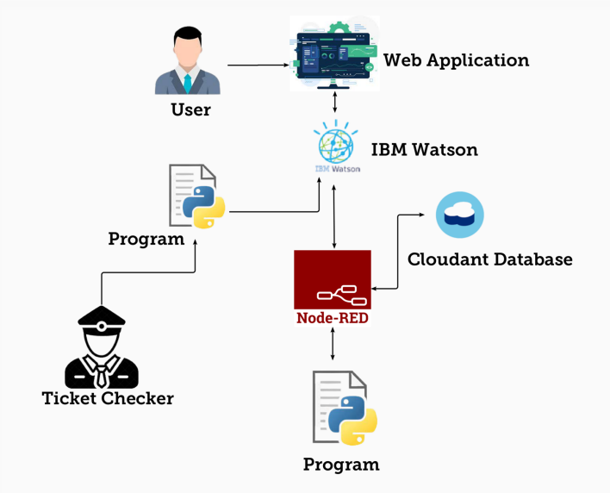

**5.3 USER STORIES**

| **User Type** | **Functional Requirement (Epic)** | **User Story Number** | **User Story / Task** | **Acceptance criteria** | **Priority** | **Release** |
| --- | --- | --- | --- | --- | --- | --- |
| Passenger | Registration | USN-1 | As a Passenger, I can register for the application by entering my email, password, and confirming my password. | I can access my account / dashboard | High | Sprint-1 |
|  |  | USN-2 | As a Passenger, I will receive confirmation email once I have registered for the application | I can receive confirmation email & click confirm | High | Sprint-1 |
|  | Login | USN-3 | As a Passenger, I can log into the application by entering email & password | I can access my account / dashboard | High | Sprint-1 |
|  | Books Ticket | USN-4 | I can select the Train and the train route to be travelled. | I can see the Train Name and Its route in the form. | Medium | Sprint-2 |
|  |  | USN-5 | I provide the basic details such as name, age, mobile number, etc. | I can see the Basic Information in the form. | High | Sprint-2 |
|  | Selecting the Seat | USN-6 | After providing the basic information, I can select the desired seat I wanted if it is in available state. | I can see that the seat is selected for booking. | Medium | Sprint-2 |
|  | QR Code Generation | USN-7 | At last the QR Code is generated which contains the unique id through which the passenger information can be retrieved. | I can receive the QR Code which I can be screenshotted. | High | Sprint-2 |
|  | Tracking the location of Train | USN-8 | As a Passenger, I can track the exact current location of the train. | I can view the exact location of the train. | Medium | Sprint-4 |
| Administrator | Login | USN-9 | As a Administrator, I can log into the application by entering email & password | I can access my account/ dashboard | Medium | Sprint-3 |
|  | Cancel the Booking | USN-10 | As a Administrator, I can Cancel the Ticket if the information of the passenger is inappropriate. | I can receive confirmation message about the cancellation of the ticket. | Low | Sprint-4 |
| Ticket Checker | TTR Verifies the Passenger | USN-11 | As a Ticket Checker, I can scan the QR Code shown by the passenger. | I can see the passenger information in application. | High | Sprint-3 |
|  |  | USN-12 | As a Ticket Checker, I can verify the passenger using the information that displayed after scanning the QR Code. | I can verify that the passenger information is matching with the information shown by the QR Code. | High | Sprint-3 |

**PROJECT PLANNING AND SCHEDULING**

**6. PROJECT PLANNING AND SCHEDULING**

**6.1. SPRINT PLANNING & ESTIMATION**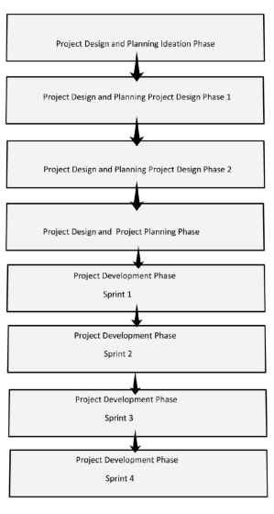

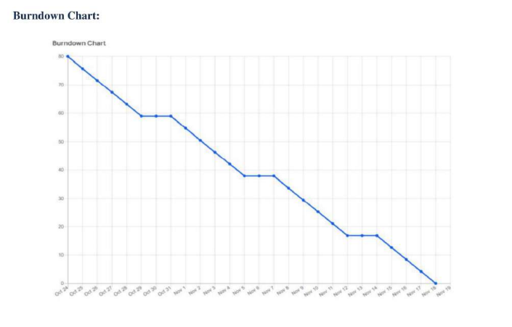

* 1. **SPRINT DELIVERY SCHEDULE**

|  |  |  |  |  |  |  |
| --- | --- | --- | --- | --- | --- | --- |
| **Sprint** | **Total Story Points** | **Duration** | **Sprint Start Date** | **Sprint End Date (Planned)** | **Story Points**  **Completed (as on Planned End Date)** | **Sprint Release Date (Actual)** |
| Sprint-1 | 20 | 6 Days | 24 Oct 2022 | 29 Oct 2022 | 20 | 29 Oct 2022 |
| Sprint-2 | 20 | 6 Days | 31 Oct 2022 | 05 Nov 2022 | 20 | 05 Nov 2022 |
| Sprint-3 | 20 | 6 Days | 07 Nov 2022 | 12 Nov 2022 | 20 | 12 Nov 2022 |
| Sprint-4 | 20 | 6 Days | 14 Nov 2022 | 19 Nov 2022 | 20 | 19 Nov 2022 |



**CODING AND SOLUTIONING**

1. **CODING AND SOLUTIONING**

**7.1. FEATURE**

* IOT device
* IBM Watson platform
* Node red
* Cloudant DB
* Web UI
* Python code

**7.2. FEATURE**

* Verification
* Ticket Booking
* Ticket Cancellation
* Know your location
* Available Seats
* QR Generation
* TC Verifiaction made easy
* Details stored at Database (DB)

**PYTHON CODE FOR TRAIN LOCATION:**

import wiotp.sdk.device  
import time  
import random  
myConfig = {  
 "identity": {  
 "orgId": "ojhlri",  
 "typeId": "GPS",  
 "deviceId":"12345"  
 },  
 "auth": {  
 "token": "12345678"  
 }  
}  
  
def myCommandCallback (cmd):   
 print ("Message received from IBM IoT Platform: %s" % cmd.data['command'])   
 m=cmd.data['command']  
  
client = wiotp.sdk.device.DeviceClient(config=myConfig, logHandlers=None)  
client.connect()  
  
def pub (data):   
 client.publishEvent(eventId="status", msgFormat="json", data=myData, qos=0, onPublish=None)  
 print ("Published data Successfully: %s", myData)  
  
while True:  
 myData={'name': 'Train1', 'lat': 17.6387448, 'lon': 78.4754336}  
 pub (myData)   
 time.sleep (3)  
 myData={'name': 'Train1', 'lat': 17.6341908, 'lon': 78.4744722}  
 pub(myData)  
 time.sleep(3)  
 myData={'name': 'Train1', 'lat': 17.6340889, 'lon': 78.4745052}  
 pub (myData)  
 time.sleep (4)  
 myData={'name': 'Train1', 'lat': 17.6248626, 'lon': 78.4720259}  
 pub (myData)  
 time.sleep (3)  
 myData={'name': 'Train1', 'lat': 17.6188577, 'lon': 78.4698726}  
 pub (myData)  
 time.sleep (3)  
 myData={'name': 'Train1', 'lat': 17.6132382, 'lon': 78.4707318}  
 pub (myData)  
 time.sleep (3)  
 client.commandCallback = myCommandCallback  
client.disconnect ()

**PYTHON CODE FOR SCANNIG THE QR:**

import cv2  
import numpy as np  
import time  
import pyzbar.pyzbar as pyzbar  
from ibmcloudant.cloudant_v1 import CloudantV1  
from ibmcloudant import CouchDbSessionAuthenticator   
from ibm_cloud_sdk_core.authenticators import BasicAuthenticator  
  
authenticator = BasicAuthenticator('apikey-267fe83f32ec443b804f3c76d688d2e3', 'b1456cbe3c712c2d555623fe092c074478521354')  
service = CloudantV1(authenticator=authenticator)  
  
service.set_service_url('https://4f470103-dd2c-4f50-94e8-3439395a7935-bluemix.cloudant.com')  
  
cap= cv2.VideoCapture(0)  
font = cv2.FONT_HERSHEY_PLAIN  
  
while True:  
 _, frame = cap.read()  
 decodedObjects = pyzbar.decode (frame)  
 for obj in decodedObjects:  
 #print ("Data", obj.data)  
 a=obj.data.decode('UTF-8')  
 cv2.putText(frame, "Ticket", (50, 50), font, 2, (255, 0, 0), 3)  
  
 #print (a)  
 try:  
 response = service.get_document(  
 db='booking',  
 doc_id = a  
 ).get_result()  
 print (response)  
 time.sleep(5)  
 except Exception as e:  
 print ("Not a Valid Ticket")  
 time.sleep(5)  
  
 cv2.imshow("Frame",frame)  
 if cv2.waitKey(1) & 0xFF ==ord('q'):  
 break  
cap.release()  
cv2.destroyAllWindows()  
client.disconnect()

**TESTING**

**WEB UI for Ticket Booking and QR Code Generation**

**Node-Red Connection for Ticket Booking and QR Generation:**

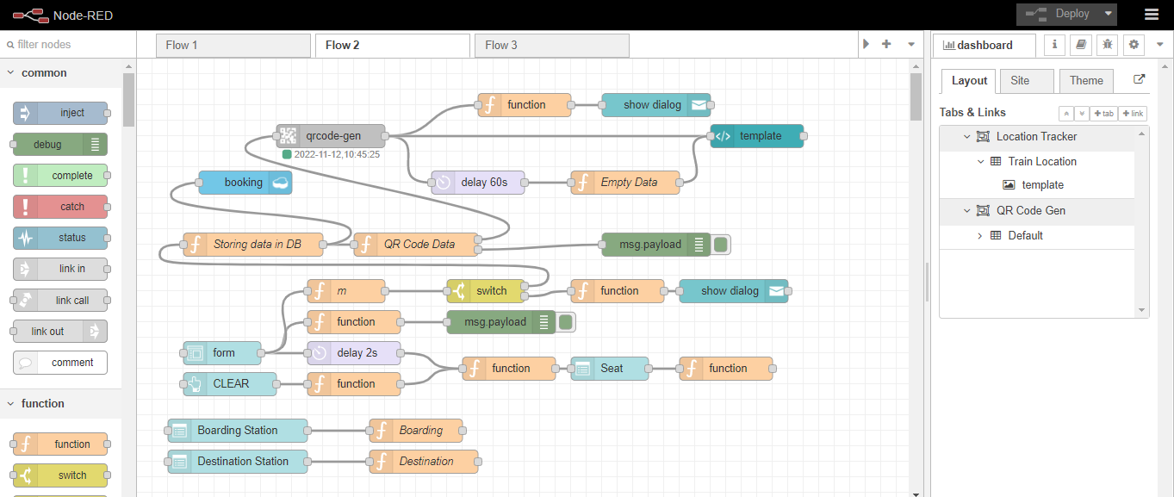

**Creation of Cloudant Database Named “Booking” to store Customer details:**

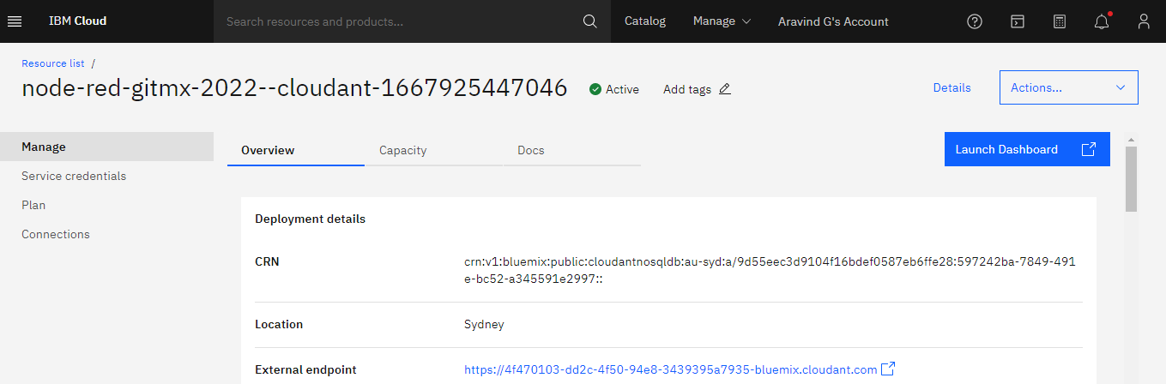

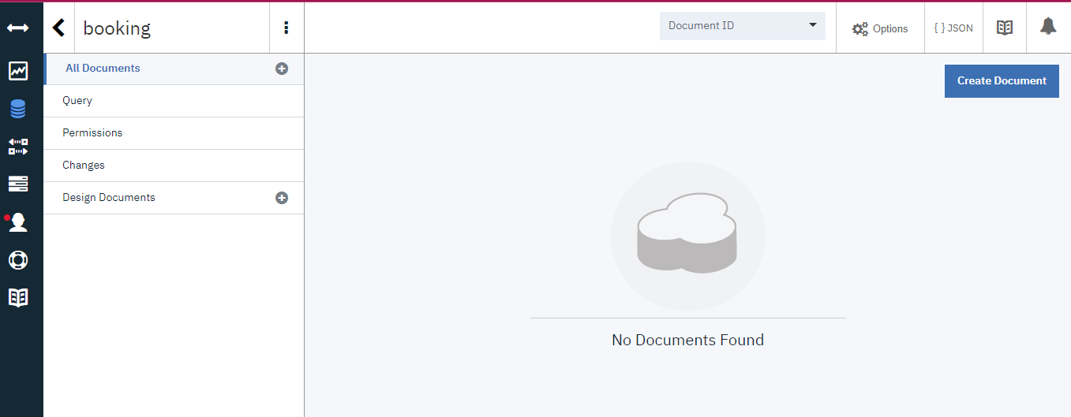

**WEB Application created from Node-Red:**

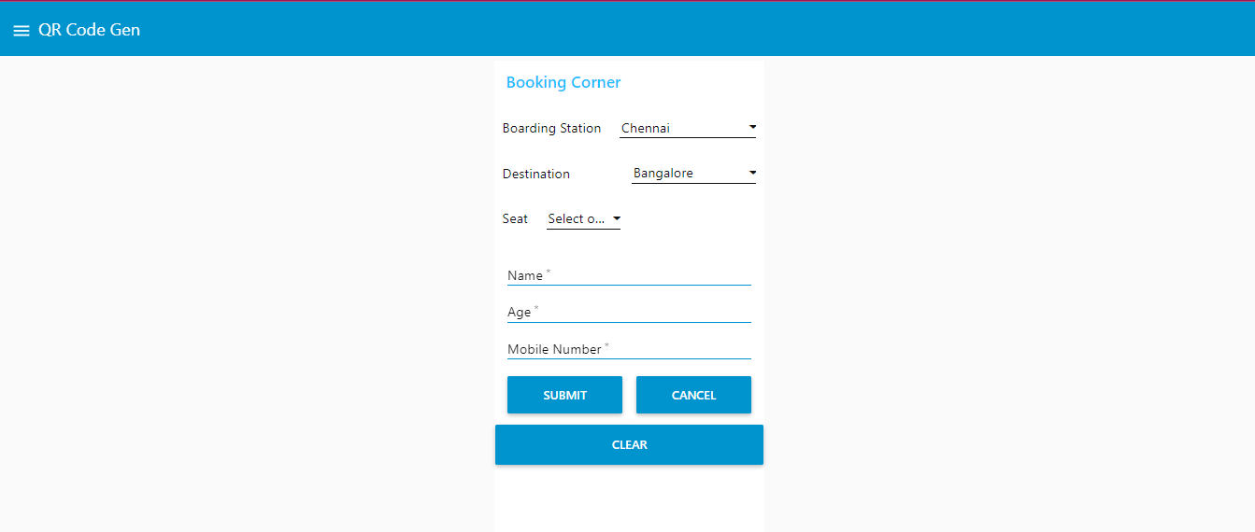

**LINK FOR Booking Corner:**

[**https://node-red-gitmx-2022-11-08.eu-gb.mybluemix.net/ui/**](https://node-red-gitmx-2022-11-08.eu-gb.mybluemix.net/ui/)

**Booking Happens :**

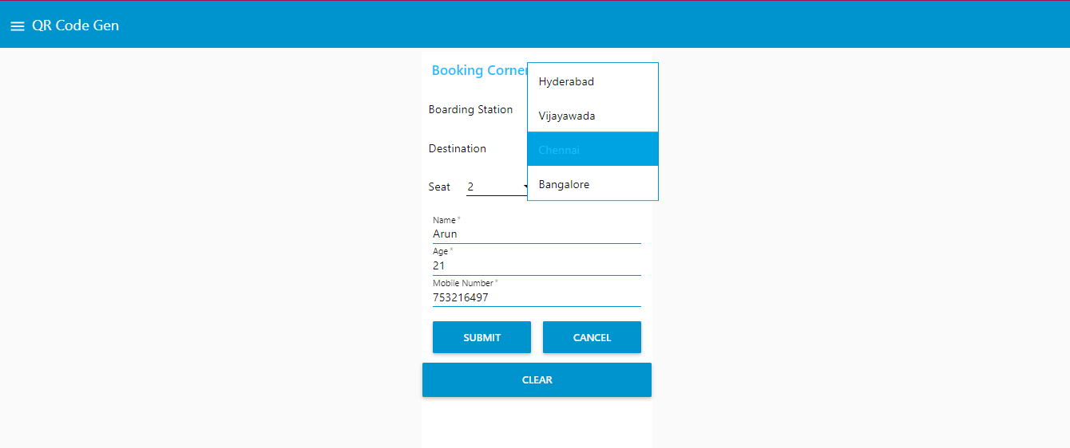

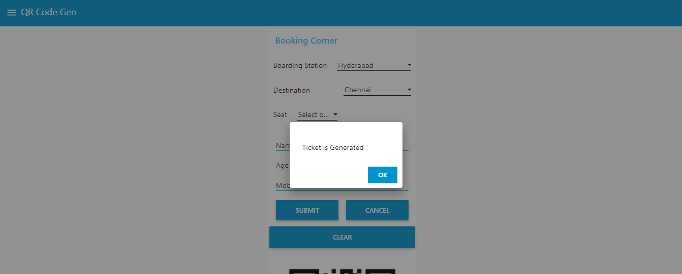

**QR Generation:**

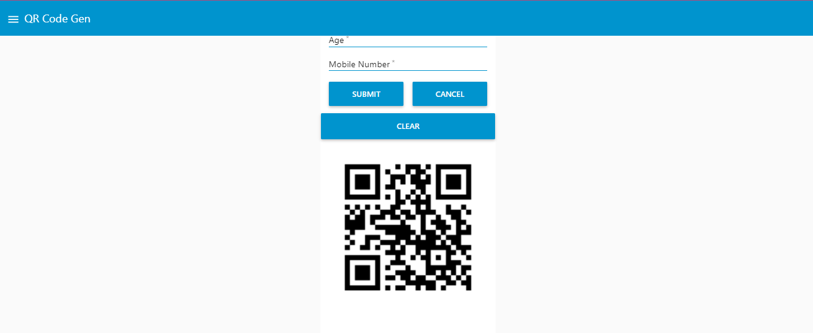

**Details will be stored at Cloudant Database:**

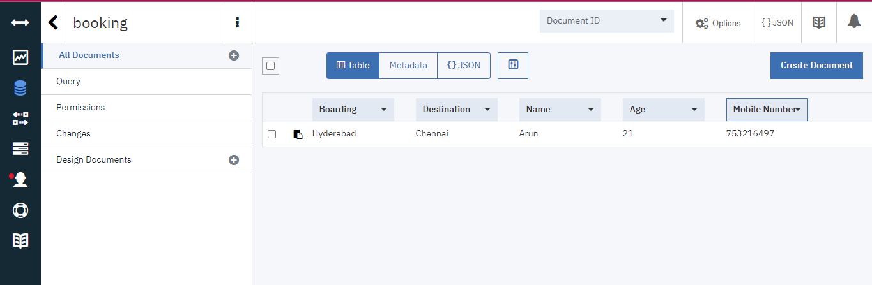

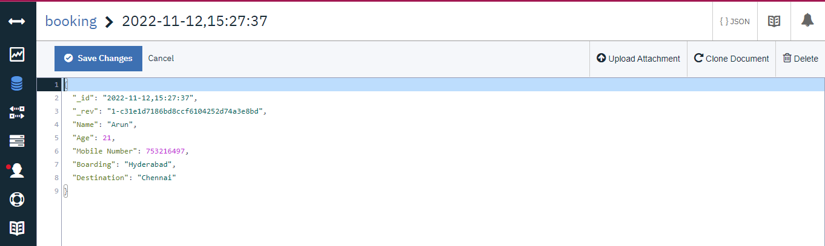

**RESULT**

**Executing the program:**

**Scanner Opens :**

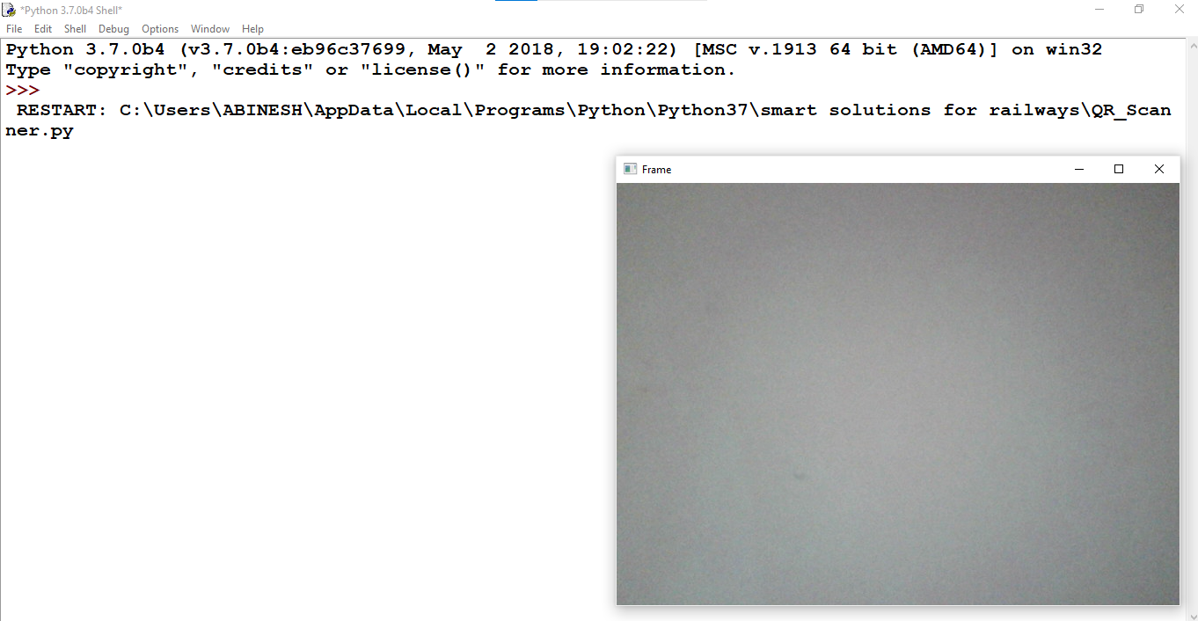

**QR is shown:**

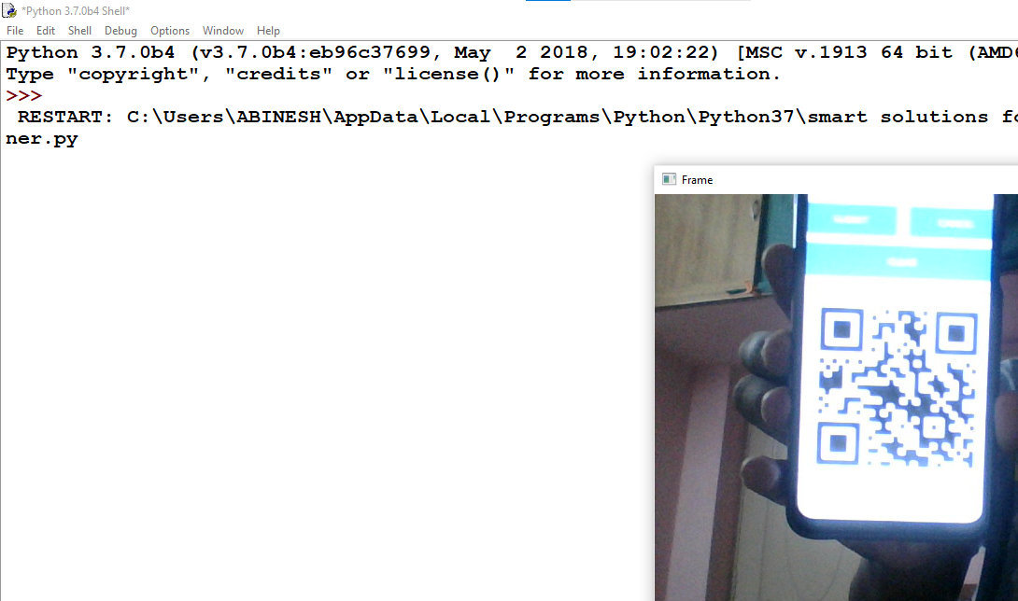

**Data Fetched from Cloud by scanning the QR:**

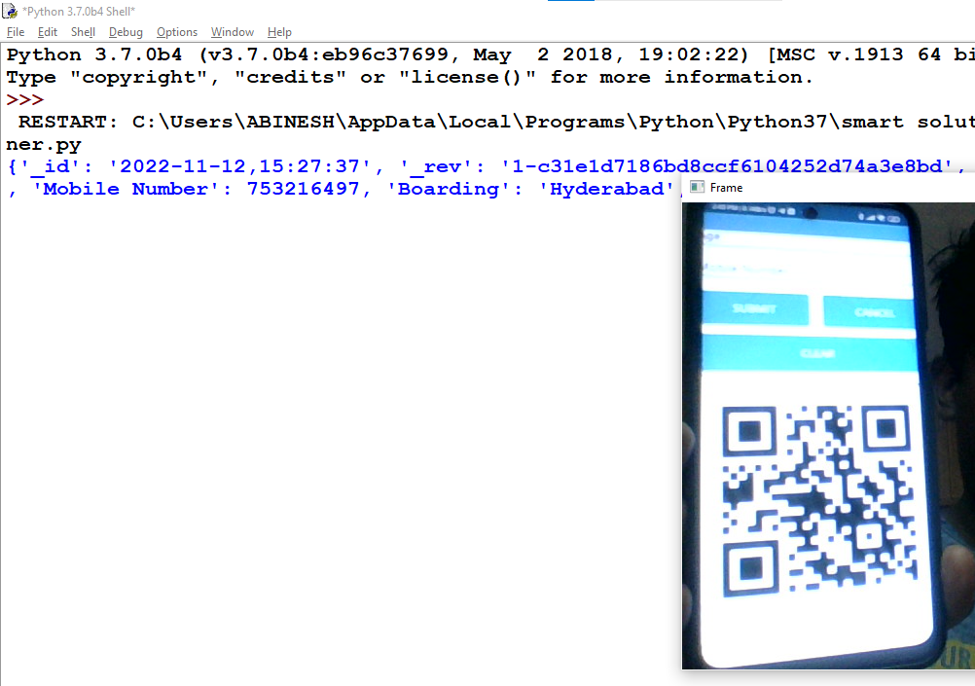

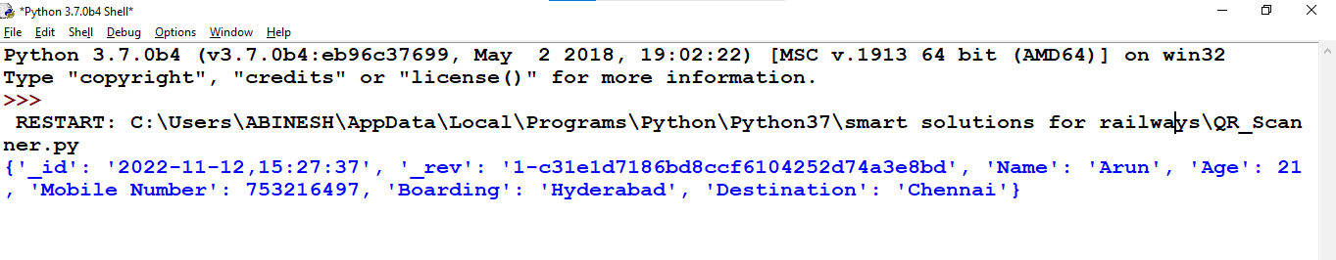

**Showing a Random Qr From Google:**



**Output: (Shows “Not a Valid Ticket”)**

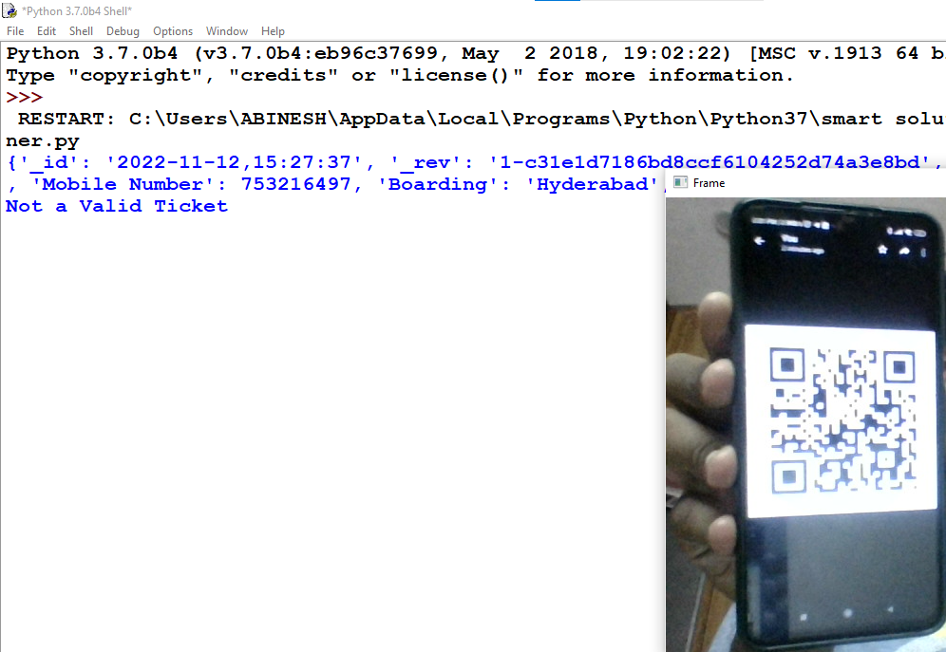

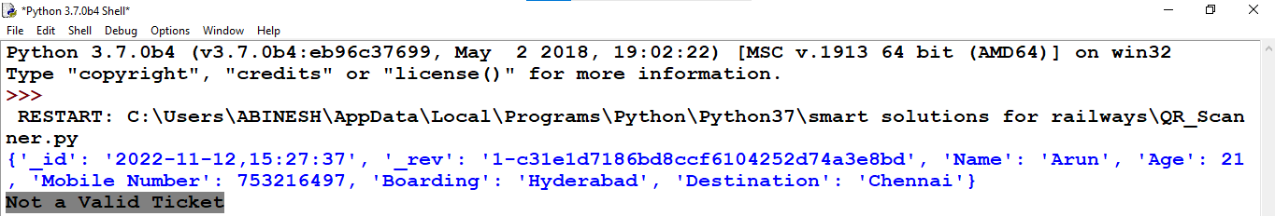

**9.1. PERFORMANCE METRICS**

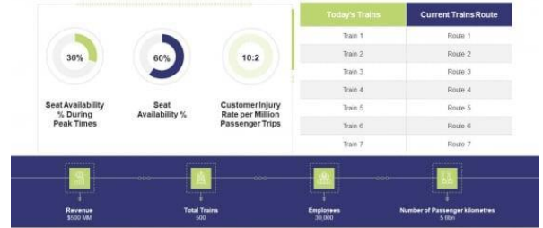

**ADVANTAGES & DISADVANTAGES**

**10. ADVANTAGES &DISADVANTAGES**

**10.1 ADVANTAGES**

* + Openness – compatibility between different systemmodules, potentially from different vendors;
  + Orchestration – ability to manage large numbers of devices, withfull visibility over them.
  + Dynamic scaling – ability to scale the system according to the application needs, through resource virtualization and cloud operation
  + Automation – ability to automate parts of the systemmonitoringapplication, leading to better performance and lower operation costs.

**10.2.DISADVANTAGES**

* + Approaches to flexible, effective, efficient, and low-cost data collection for both railway vehicles and infrastructure monitoring, using regular trains
  + Data processing, reduction, and analysis in local controllers, andsubsequent sending of that data to the cloud, for further processing
  + Online data processing systems, for real-time monitoring, usingemerging
  + communication technologies
  + Integrated, interoperable, and scalable solutions for railway systemspreventive maintenance.

**CONCLUSION**

**11. CONCLUSION**

Accidents occurring in Railway transportation systemcost a largenumber of lives. So this system helps us to prevent accidents andgivinginformation about faults or cracks in advance to railway authorities. Sothat they can fix them and accidents cases becomes less. This project iscost effective. By using more techniques they can be modifiedanddeveloped according to their applications. By this systemmany lives canbe saved by avoiding accidents. The idea can be implemented inlargescale in the long run to facilitate better safety standards for rail tracks andprovide effective testing infrastructure for achieving better results inthefuture.

**FUTURE SCOPE**

**12. FUTURE SCOPE**

In future CCTV systems with IP based camera can be usedfor monitoring the visual videos captured from the track. It will also increasesecurity for both passengers and railways. GPS can also be used todetect exact location of track fault area, IP cameras can also be used toshowfault with the help of video. Locations on Google maps with the helpof sensors can be used to detect in which area track is broken.

**APPENDIX**

**13. APPENDIX**

**13.1. SOURCE PROGRAM**

**LOCATION TRACKER:**

import wiotp.sdk.device

import time

import random

myConfig = {

"identity": {

"orgId": "ojhlri",

"typeId": "GPS",

"deviceId":"12345"

},

"auth": {

"token": "12345678"

}

}

def myCommandCallback (cmd):

print ("Message received from IBM IoT Platform: %s" % cmd.data['command'])

m=cmd.data['command']

client = wiotp.sdk.device.DeviceClient(config=myConfig, logHandlers=None)

client.connect()

def pub (data):

client.publishEvent(eventId="status", msgFormat="json", data=myData, qos=0, onPublish=None)

print ("Published data Successfully: %s", myData)

while True:

myData={'name': 'Train1', 'lat': 17.6387448, 'lon': 78.4754336}

pub (myData)

time.sleep (3)

myData={'name': 'Train1', 'lat': 17.6341908, 'lon': 78.4744722}

pub(myData)

time.sleep(3)

myData={'name': 'Train1', 'lat': 17.6340889, 'lon': 78.4745052}

pub (myData)

time.sleep (3)

myData={'name': 'Train1', 'lat': 17.6248626, 'lon': 78.4720259}

pub (myData)

time.sleep (3)

myData={'name': 'Train1', 'lat': 17.6188577, 'lon': 78.4698726}

pub (myData)

time.sleep (3)

myData={'name': 'Train1', 'lat': 17.6132382, 'lon': 78.4707318}

pub (myData)

time.sleep (3)

client.commandCallback = myCommandCallback

client.disconnect ()

**PYTHON CODE FOR QR SCANNER:**

import cv2

import numpy as np

import time

import pyzbar.pyzbar as pyzbar

from ibmcloudant.cloudant_v1 import CloudantV1

from ibmcloudant import CouchDbSessionAuthenticator

from ibm_cloud_sdk_core.authenticators import BasicAuthenticator

authenticator = BasicAuthenticator('apikey-267fe83f32ec443b804f3c76d688d2e3', 'b1456cbe3c712c2d555623fe092c074478521354')

service = CloudantV1(authenticator=authenticator)

service.set_service_url('https://4f470103-dd2c-4f50-94e8-3439395a7935-bluemix.cloudant.com')

cap= cv2.VideoCapture(0)

font = cv2.FONT_HERSHEY_PLAIN

while True:

_, frame = cap.read()

decodedObjects = pyzbar.decode (frame)

for obj in decodedObjects:

#print ("Data", obj.data)

a=obj.data.decode('UTF-8')

cv2.putText(frame, "Ticket", (50, 50), font, 2, (255, 0, 0), 3)

#print (a)

try:

response = service.get_document(

db='booking',

doc_id = a

).get_result()

print (response)

time.sleep(5)

except Exception as e:

print ("Not a Valid Ticket")

time.sleep(5)

cv2.imshow("Frame",frame)

if cv2.waitKey(1) & 0xFF ==ord('q'):

break

cap.release()

cv2.destroyAllWindows()

client.disconnect()

**13.2 GITHUB LINK**

[**https://github.com/IBM-EPBL/IBM-Project-3047-1658498553**](https://github.com/IBM-EPBL/IBM-Project-3047-1658498553)

**13.3 DEMO LINK**

[**https://drive.google.com/file/d/1S2F-prciLIp0tscZ0r1m4cfbqhEVhrsR/view?usp=share_link**](https://drive.google.com/file/d/1S2F-prciLIp0tscZ0r1m4cfbqhEVhrsR/view?usp=share_link)